RFID Based Smart Master Card For Bus Train Metro Ticketing
Modern cities of today have developed multiple means of communication including Buses, trains, metros and private vehicles. Now each transport system has their own smart card and it becomes a hectic process for users to manage separate smart cards for every transport medium. Thus we propose a smart master card approach that integrates all these systems together and allows for a single master card and a centralized system for all transportation mediums. To demonstrate this concept we use three RFID scanners to demonstrate as bus train and metro train smart card scanners respectively. Now we use three smart cards that work particularly on each of the systems viz one rfid card for bus, one for train and one for metro respectively. Now we also provide one more card that is the master smart card that can work on all three scanners thus making it very easy for the user to use any transport as desired using the same card. The system also allows for source and destination selection and based on that deducts particular amount from the user master card.

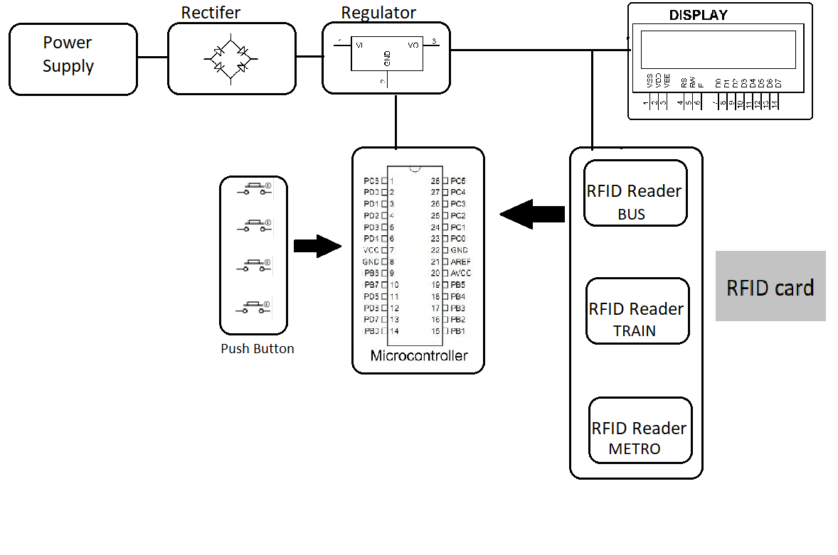
Hardware Specifications
- RFID Scanners
- RFID Cards
- Atmega Microcontroller
- LCD Display
- Power Supply
- Buzzer
- IC’s
- Resistors
- Capacitors
- LED’s
- Diodes

Software Specifications
- Arduino Compiler
- MC Programming Language: C

